SOCIALIST REPUBLIC OF VIETNAM
Independence - Freedom – Happiness
__________________________



Certificate
Of Land use right,
housing ownership and OTHER ASSETS attached to LAND

I. Land user, housing owner and other assets attached to land
Mr. Ho Sy Trong
Year of birth: 1994 Citizen ID Card No.: 040094022524
Permanent address: Tho Thanh Commune, Yen Thanh District, Nghe An Province
Mrs. Nguyen Thi Thuy
Year of birth: 2003 Citizen ID Card No.: 040303007220
Permanent address: Tho Thanh Commune, Yen Thanh District, Nghe An Province

DO 150433
II. Land Lot, house and other assets attached to land
1. Land Lot
a) Land Lot No.: 411 Map sheet No.: 27,
b) Address: Hamlet 8, Tho Thanh Commune, Yen Thanh District, Nghe An Province
c) Area: 141.9 m² (In words: One hundred forty one point nine square meters)
d) Use form: Private
e) Use purpose: Rural residential land: 100.0 m²; Land for perennials: 41.9 m²,
f) Use period: Rural residential land: Long-term, Land for perennials: Until 12/04/2045;
g) Use source: Received the land via transfer with land use right recognized as allocated with land use fee: 100.0 m²; Received the land via transfer with land use right recognized as allocated without land use fee: 41.9 m²
2. House: -/-
3. Other construction works: -/-
4. Production forest as planted forest: -/-
5. Long-term plant: -/-
6. Notes:
- Received via transfer from Certificate No. DN 284291, issued on November 23rd, 2023.

Yen Thanh, March 12th, 2024
BRANCH OF LAND REGISTRATION OFFICE
YEN THANH DISTRICT
DIRECTOR
(Signed & sealed)
Nguyen Van Doan

Registered in Certificate Issuing Book: CN02539
III. Plan of land lot, house and other assets attached to land
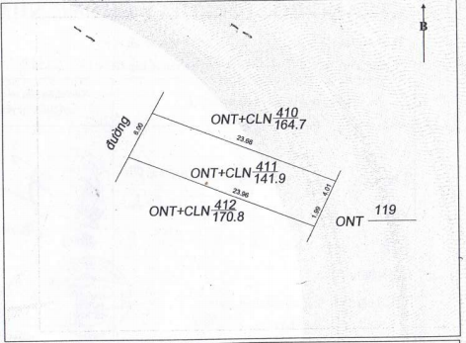
IV. Changes after issuance of the certificate
Changed contents and legal bases | Confirmation of authorized agency
CERTIFIED TRUE COPY OF ORIGINAL
Certification No. 1029 Volume No. 01 SCT/BS
Date: 18-08-2026
DIRECTOR
(signed and sealed)
Nguyen Van Trung

ADDITIONAL PAGE OF CERTIFICATE
Land lot No.: 411 Map sheet No.: 27
Certificate issue number: DO 150433
Registered in Certificate Book No. CN 02539
This additional page must be attached to the Certificate to be valid.

 | Contents of change and legal bases | Confirmation of authorized agencies
02/04/2024 | Mortgaged by using the land use right at Agribank, branch of Yen Thanh District, Nghe An, Tho Yen Transaction Office according to Record No. TC 2769 | (Signed & sealed)  Hoang Van Trong
17/08/2026 | Deleted the mortgage registration dated 02/04/2024 according to Record No. XC.5673. | (Signed & sealed)  Tran Trung Hieu

Additional page No. 01

